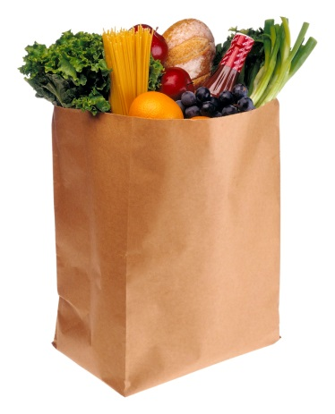
Food Drive for Food at First

Items Immediately Needed:
- Cheddar cheese
- Flour
- Granulated sugar
- Brown sugar
- Vegetable oil
- Olive oil
- Salt
- Spices - ground powdered garlic, cinnamon
- Cider vinegar
- Lemon juice
- Juices, variety for beverage service
- Mayonnaise / Miracle Whip
- Ranch salad dressing
- Oatmeal, quick-cooking
- Onions, yellow plus dehydrated
- Beef and/or chicken broth
- Spaghetti sauce
- Vegetables, canned, assorted
- Fruit, canned, assorted
- Pan spray
- Aluminum foil, heavy duty
- Trash bags, 45-gal, heavy duty
- Paper towels
- Scotch-brite, SOS, other scrubbing pads
- Bar towels, tea towels
- Plastic wrap, press-n-seal wrap
- Dawn dishwashing soap
- Napkins
- Sharpies

